REMEMBER RETINA DANCE IN YOUR WILL

By making a bequest in the favour of Retina Dance Company, you can guarantee the future of an extraordinary dance company and that of contemporary dance for generations to come.

Retina Dance Company is committed to working with children and young people, especially in schools, developing an interest in and what we hope will become, a life-long passion for contemporary dance to enjoy either as a participant, audience member, or as a career option.

We also create and tour exciting and innovative contemporary dance pieces, allowing us to work with local communities to develop opportunities for non-professionals to join in and enjoy our work.

The arts in this country are at risk, but by your kindness in remembering us in your Will enables great art to continue to happen and for everyone. Especially the next generation of potential dancers.

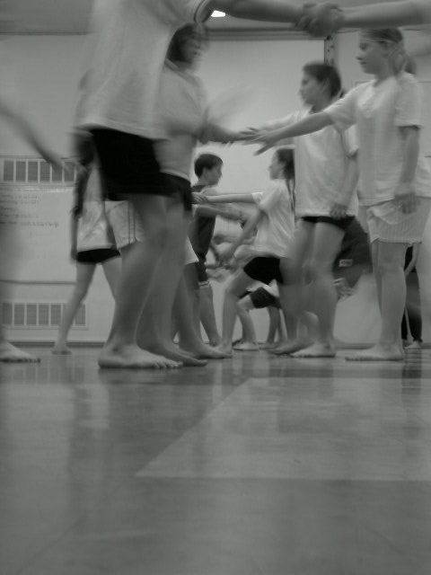
The picture above shows a typical school session teaching the children basic movement techniques.
And the following is just some of the feedback we receive regularly from our education work in schools.

“Our students thought it was fantastic, they took everything from it and it has really helped them.”

“The children had a great time and the member of staff involved in the session was very impressed with the standard of teaching.”

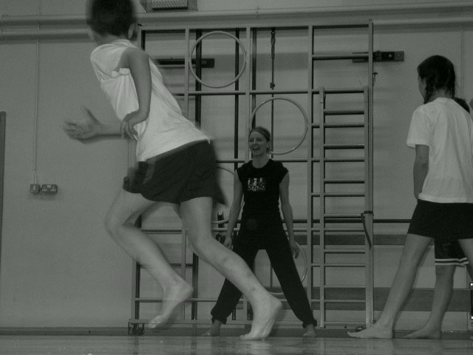

“Ian came to our school to run two dance workshops yesterday. We thought he was fabulous. The children were engaged, motivated and thoroughly enjoyed themselves. Ian kept the children challenged and active for the full session and they were able to learn a completely different and new style of dance they had not experienced before.”

If you would like further information, or want to discuss remembering Retina Dance Company, please get in touch with Kevan Jackson, General Manager. You can call Kevan on 0115 9476202 extension 224, email him on manager@retinadance.com or write to him at College Street Centre, College StreetNottingham NG1 5AQ

